Requirements Analysis:
- Rob made a Requirement Specification document found here
- Decided to use Java as our programming language as it was previously used for Byfter

Architectural Design:
- Wiktor created a Conceptual view diagram and a Use Case diagram for our program Fresh Time
  - 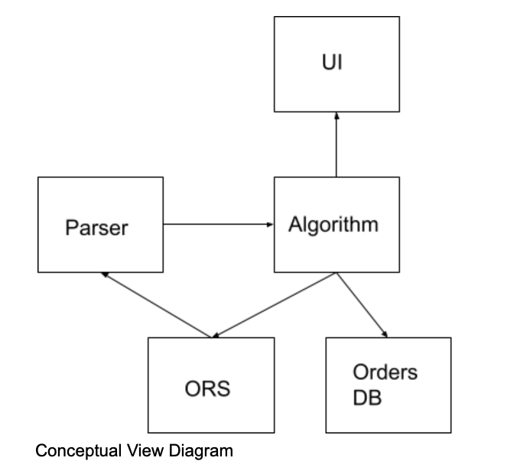

System Modeling:
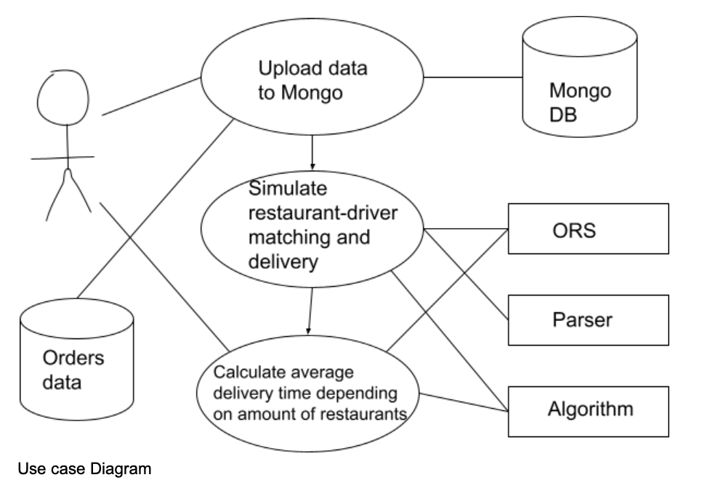

Advanced SWE Topics:
- Looked at and learned the basics of mySQL to use as our Relational Database Management System (RDBMS) link
  - Possible alternative to MongoDB
- Rob made software reuse document for information about reused components from minor projects.

